SWIFT SHIP TRACKER

Team Lead: P.Sharmila
Team member:
V.Mugilvani
S.Thulasi
M.Gokula sankar
Dept: B.E Computer Science and Engineering

Phase 1: Requirement Analysis & Planning Project Type: Salesforce Developer Project
Project Objective:
To simplify parcel booking, tracking and delivery management using Salesforce automation and AgentForce AI capabilities.

1. Project Overview
Swift Ship Tracker is a Salesforce-based parcel delivery management project designed to simplify parcel booking, tracking and delivery management.
The project aims to provide a centralized system for managing parcel information, sender details, receiver details and delivery information. It also focuses on reducing confusion and improving the delivery management process.
The project uses Salesforce features such as Custom Objects, Salesforce Flows, Prompt Builder, Permission Sets and AgentForce AI to support parcel management, automation and conversational interaction.
The major users of the system are Customers, Delivery Agents and Administrators.

2. Problem Statement
Customers may face delays and confusion while booking, tracking and managing parcel deliveries.
Delivery agents also need an organized way to manage delivery information and update parcel status.
Therefore, the Swift Ship Tracker project aims to provide a centralized Salesforce-based solution that simplifies parcel booking, tracking and delivery management.

3. Project Objectives
The main objectives of the Swift Ship Tracker project are:
- To simplify parcel booking.
- To provide parcel tracking functionality.
- To manage sender and receiver information.
- To manage delivery information.
- To provide delivery status updates.
- To automate parcel and delivery-related processes.
- To reduce confusion in parcel delivery management.
- To use Salesforce automation features for efficient processing.
- To use AgentForce AI for conversational assistance.
- To provide a structured and centralized parcel management system.

Project Scope
The scope of the Swift Ship Tracker project includes:
- Parcel information management.
- Sender information management.
- Receiver information management.
- Delivery information management.
- Parcel tracking.
- Delivery status updates.
- Automation using Salesforce Flows.
- AI-based assistance using AgentForce.
- Prompt-based functionality using Prompt Builder.
- User access management using Permission Sets.
The project involves three major user roles:
- Customer ● Delivery Agent ● Admin

5. User Personas & Requirements
5.1 Customer
The customer is the person who books and tracks a parcel.
Requirements:
- Book a parcel.
- Provide sender and receiver information.
- Track parcel information.
- View delivery status.
- Get assistance through the conversational AI agent.

5.2 Delivery Agent
The delivery agent is responsible for handling delivery-related activities.
Requirements:
- View delivery information.
- Manage delivery details.
- Update delivery status.
- Access required parcel information.
- Work with delivery-related automation.

5.3 Admin
The administrator manages and monitors the overall system.
Requirements:
- Manage parcel information.
- Manage sender and receiver information.
- Manage delivery information.
- Monitor the overall system.
- Manage user access and permissions.
- Monitor automated processes.

Salesforce Features & Tools
The project uses the following Salesforce features and tools:

Salesforce Custom Objects
Custom objects are used to store project-related information.
The main custom objects are:
- Parcel
- Sender
- Receiver
- Delivery

Salesforce Flows
Flows are used to automate parcel and delivery-related processes, including status updates and approval-related processes.

Prompt Builder
Prompt Builder is used to create prompt-based functionality for the project.

AgentForce AI
AgentForce AI is used to provide conversational assistance and interact with users.

Permission Sets
Permission Sets are used to provide appropriate access and permissions to users.

Data Model
The Swift Ship Tracker project uses four major custom objects:
Parcel
Stores parcel-related information.
Sender
Stores information about the person sending the parcel.
Receiver
Stores information about the person receiving the parcel.
Delivery
Stores delivery-related information.

Basic Relationship Structure
Document-la indha diagram-ai podu:
SWIFT SHIP TRACKER
|
PARCEL
/ | \
/ | \
SENDER RECEIVER DELIVERY
The data model connects parcel information with sender, receiver and delivery information to support structured parcel management.

Security Model
Security and access control are considered based on the different user roles.

Customer
Customers should have access to the parcel and delivery information relevant to their activities.

Delivery Agent
Delivery agents should have access to the information required to perform delivery-related activities.

Admin
Administrators should have broader access to manage and monitor the overall system.
Permission Sets and Salesforce access controls are used as part of the project's security approach.

10. Project Workflow
The overall project workflow can be represented as:
Customer
↓
Parcel Booking
↓
Parcel Information
↓
Sender + Receiver Details
↓
Delivery Processing
↓
Delivery Status Update
↓
Parcel Tracking
↓
Successful Delivery
Salesforce automation and AgentForce AI are used to support the workflow.

Phase 2: Salesforce development & Backend Configuration
Object Creation: Parcel object
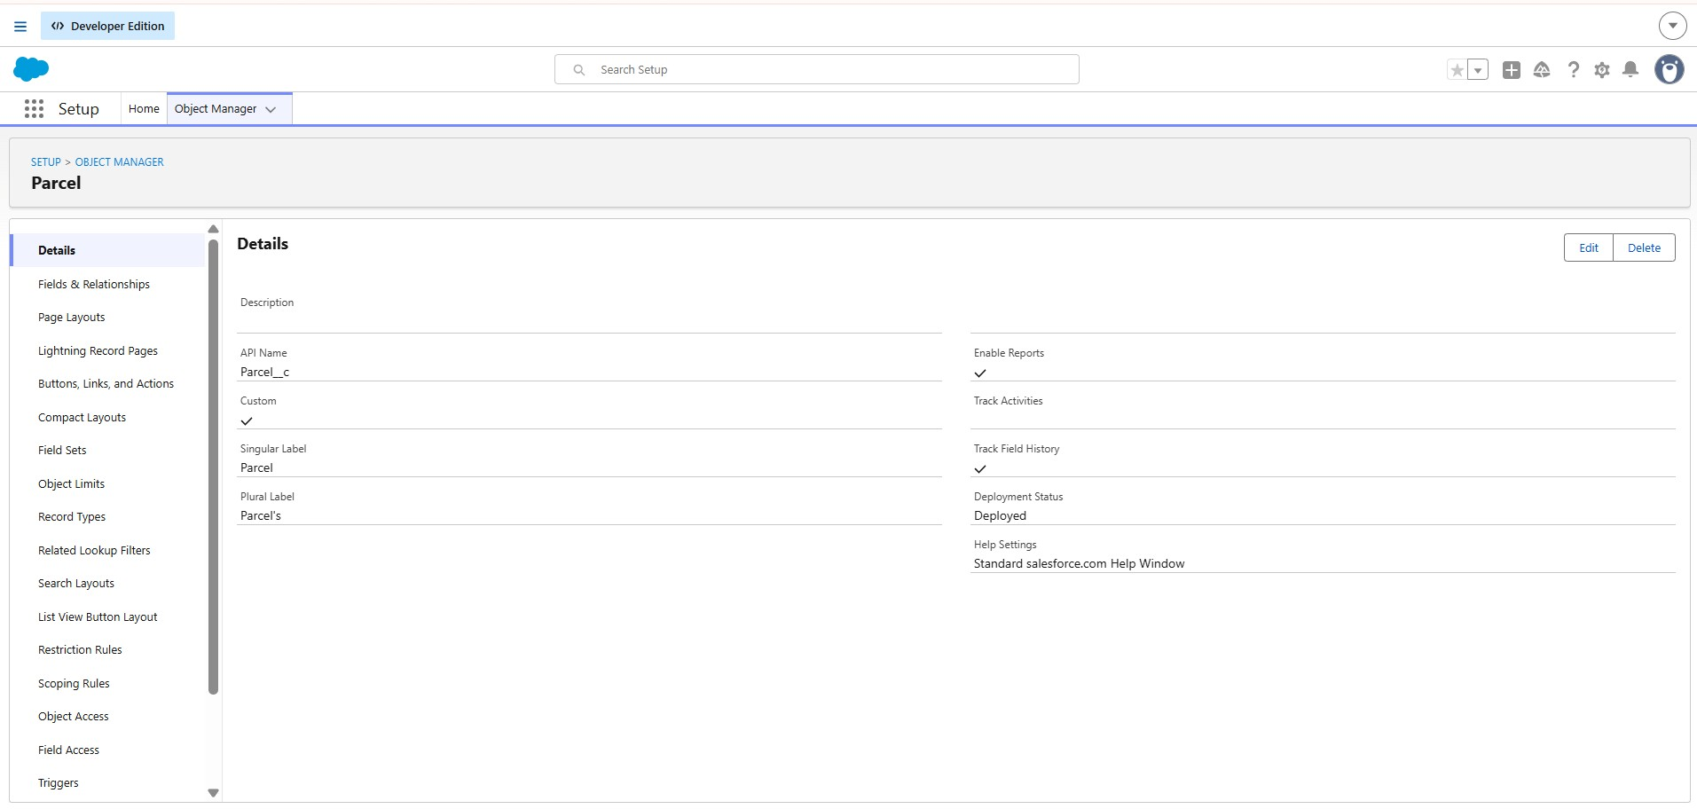
Delivery object
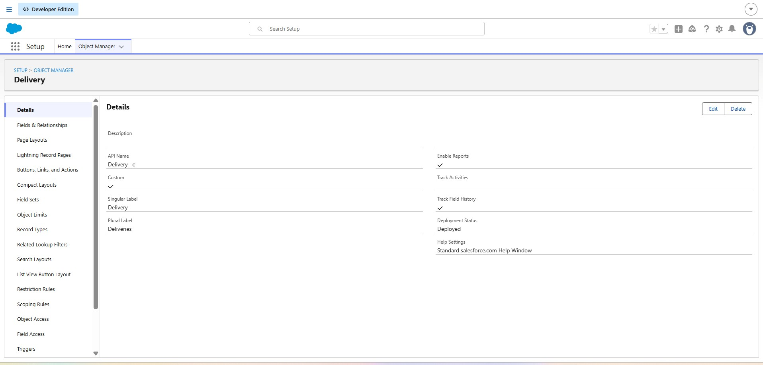

Sender object
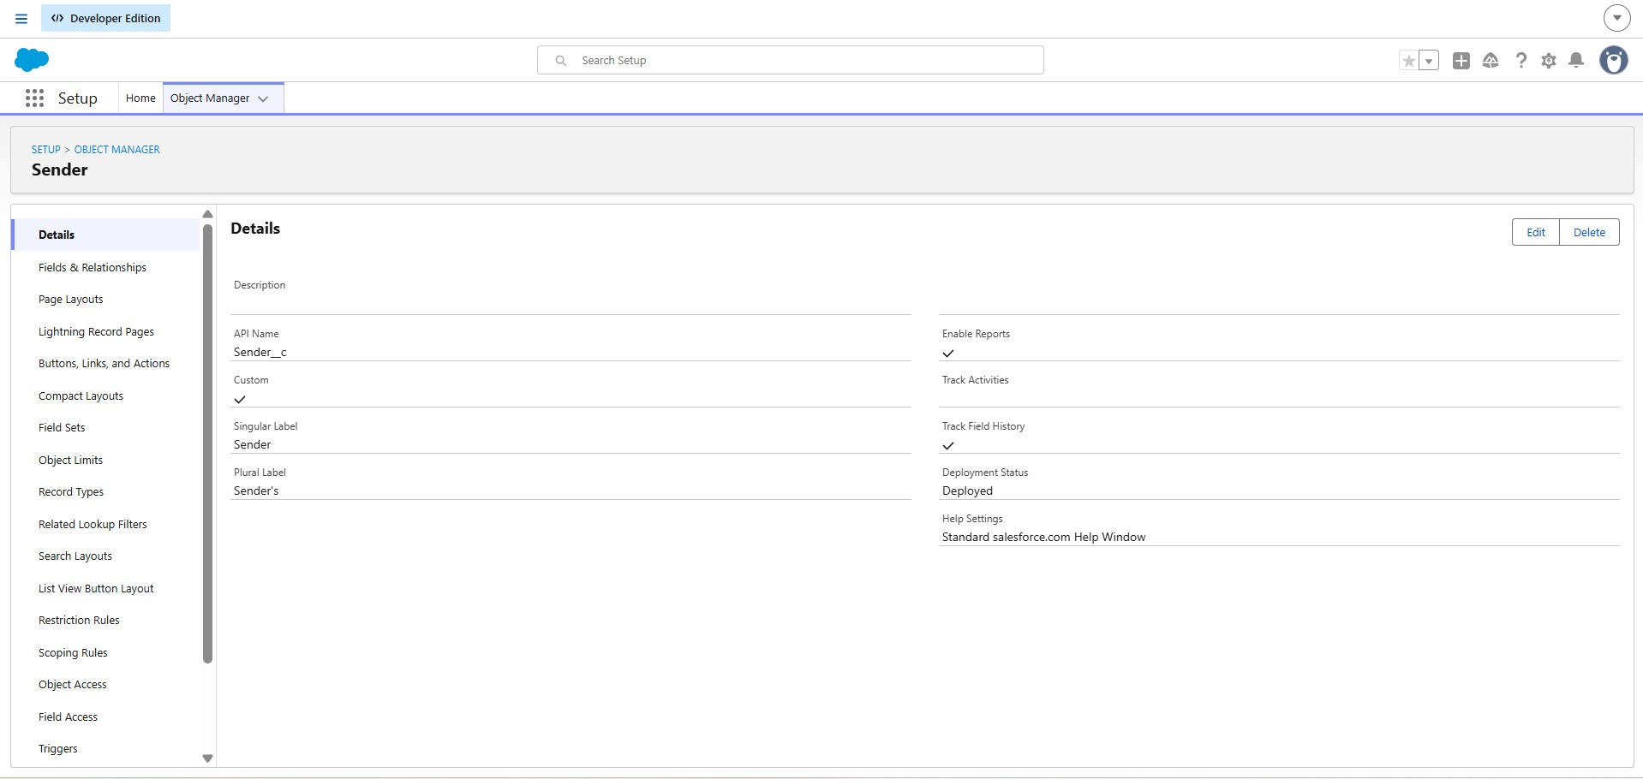

Receiver object

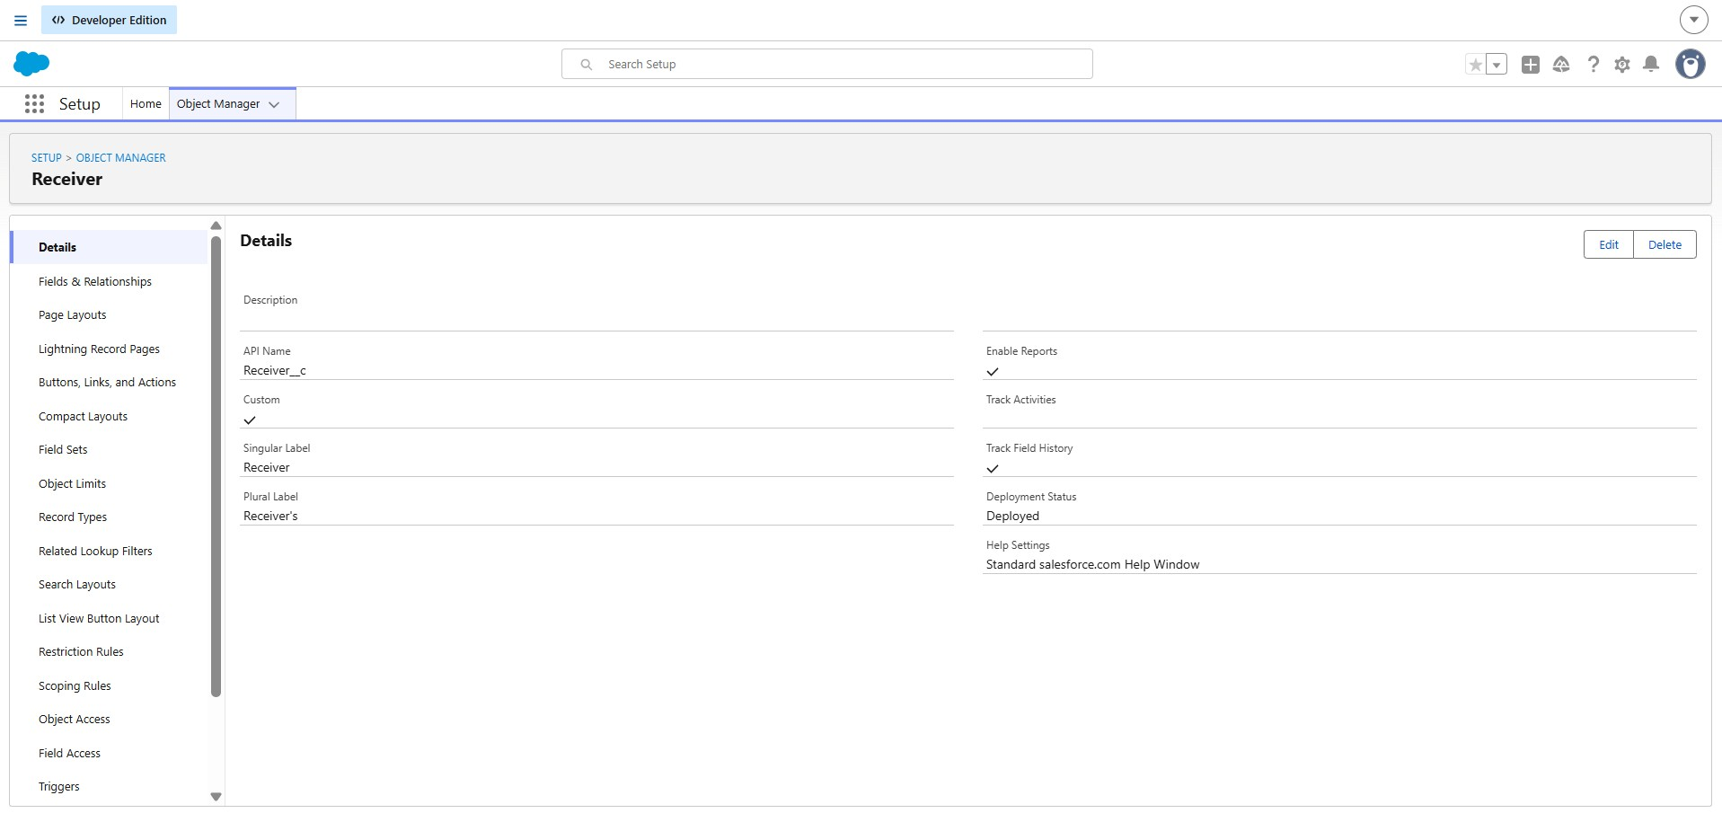

TABS:

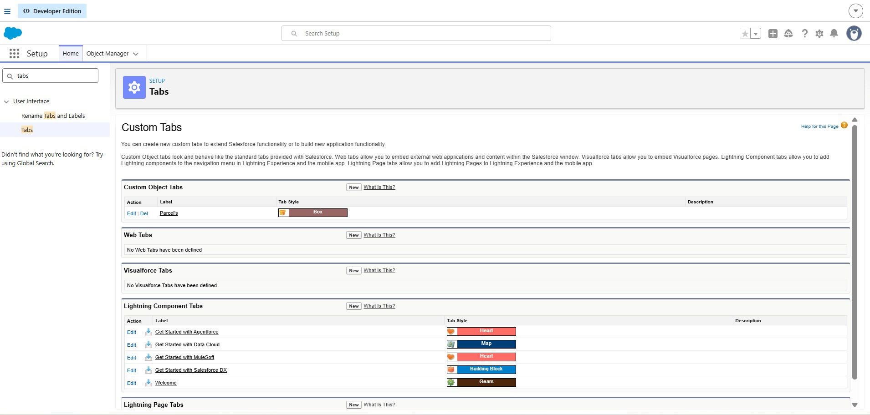

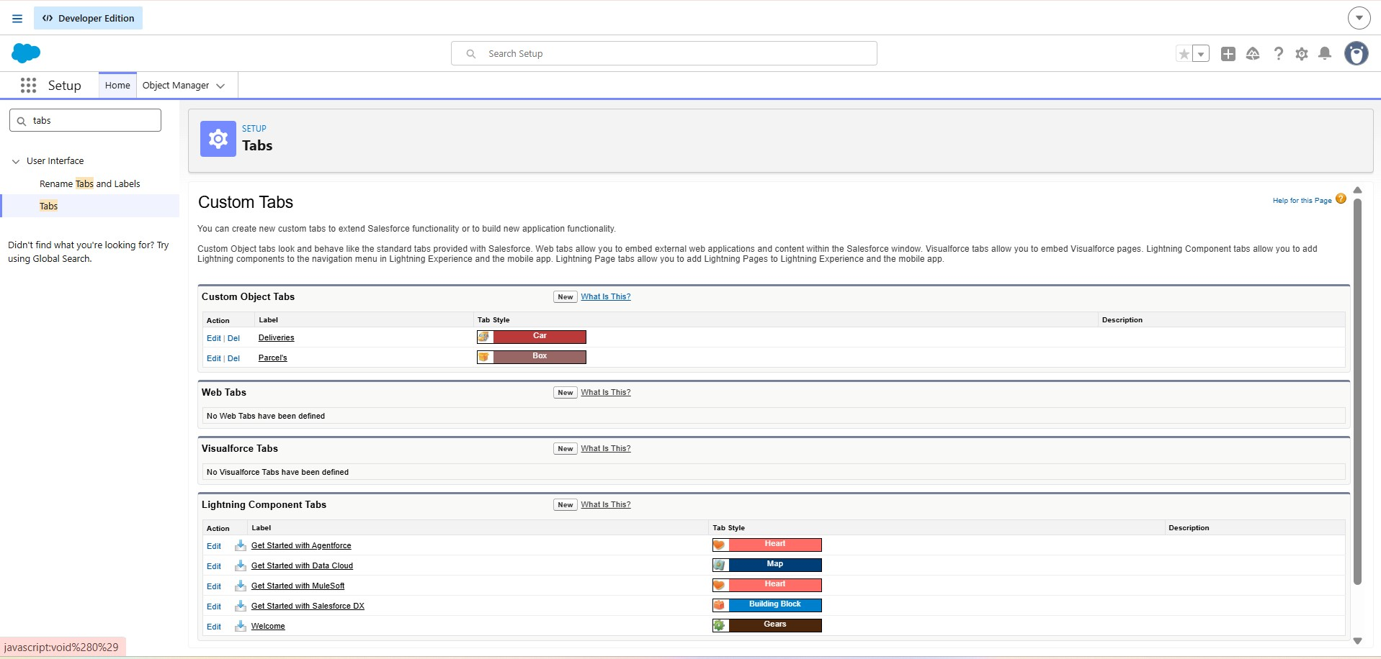

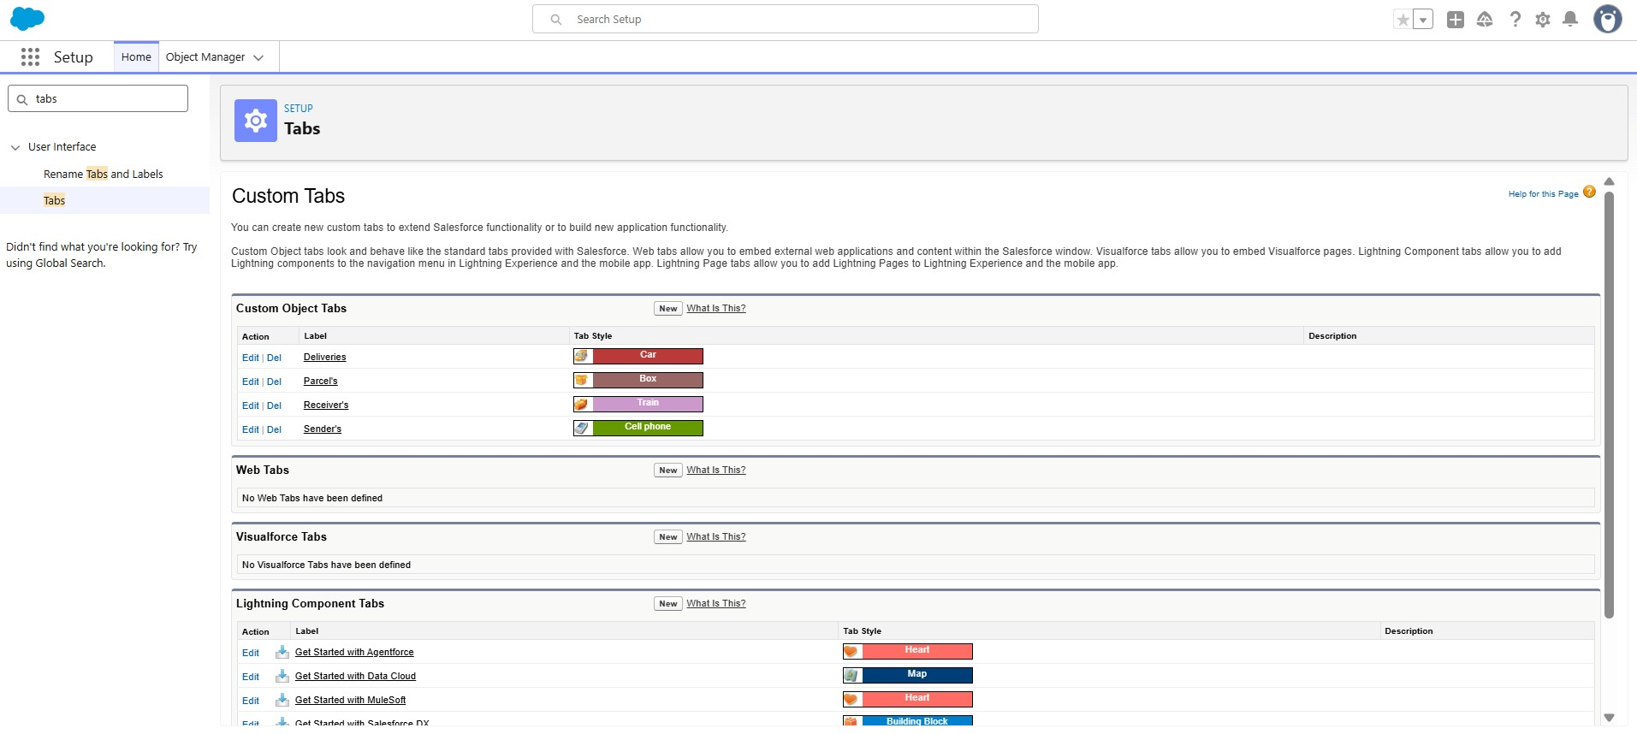

Field & relationship:
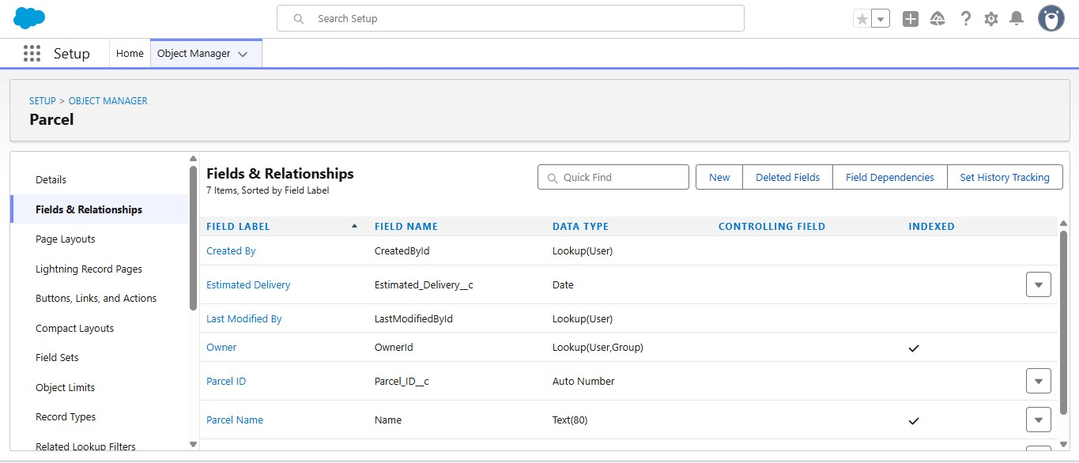
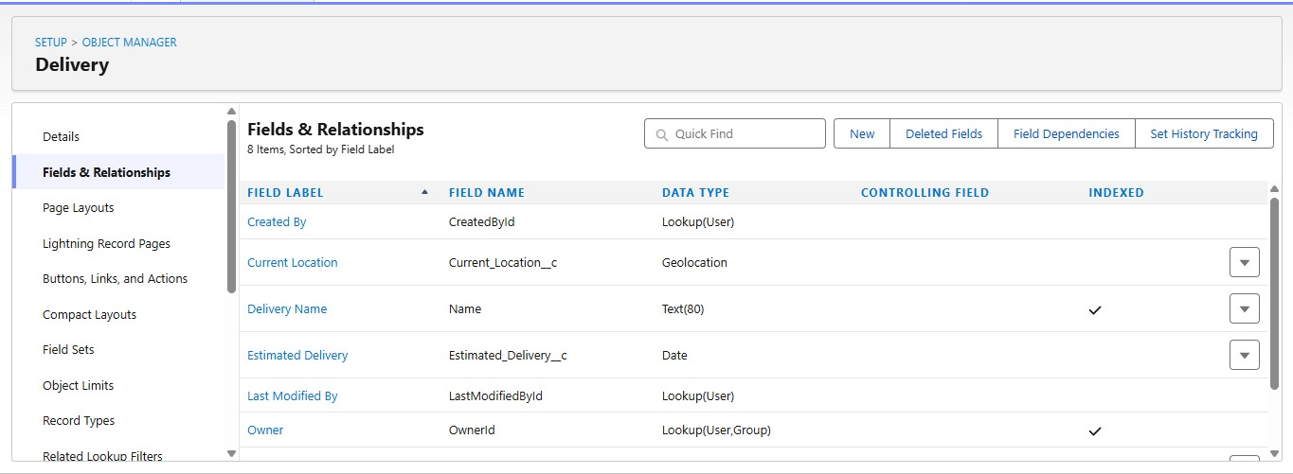

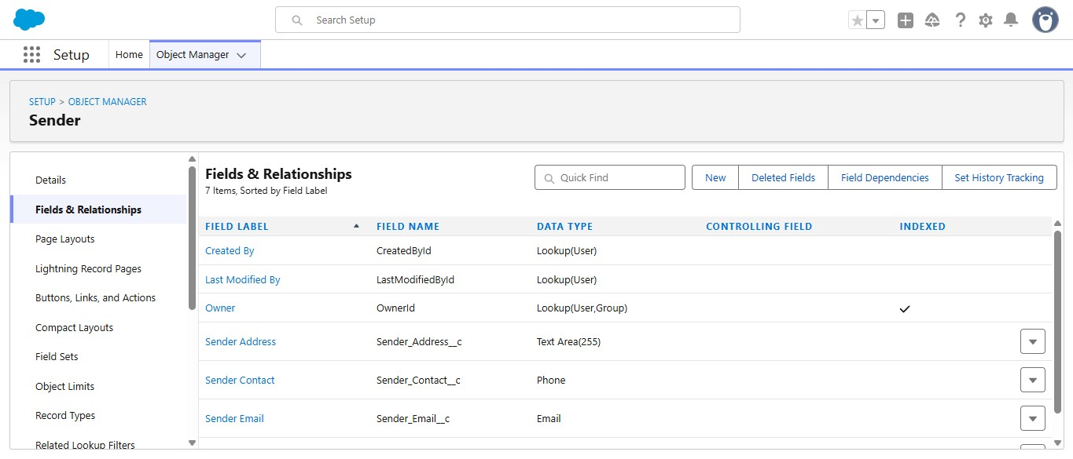

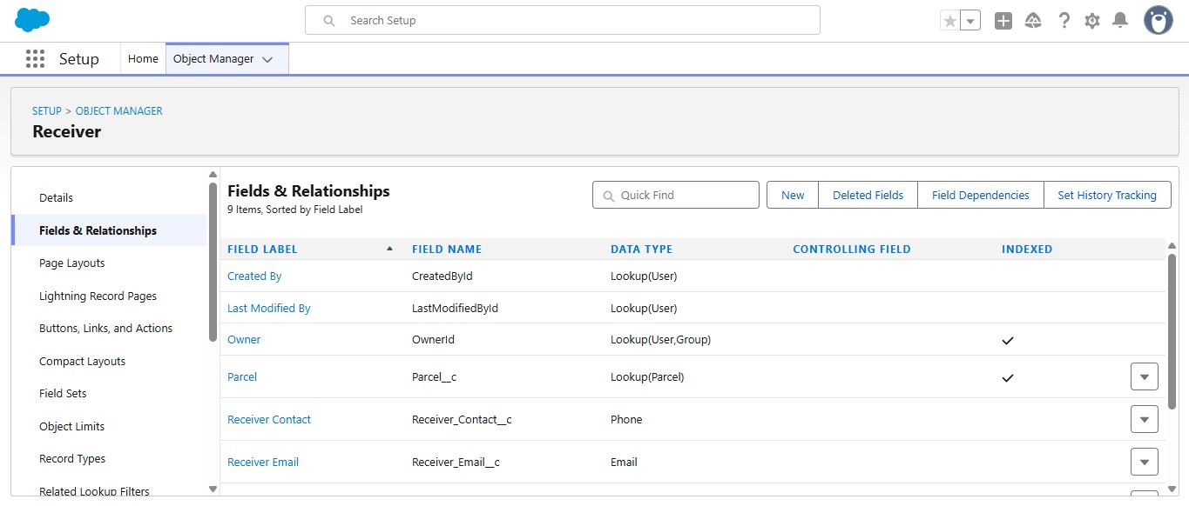
Prompt Builder:
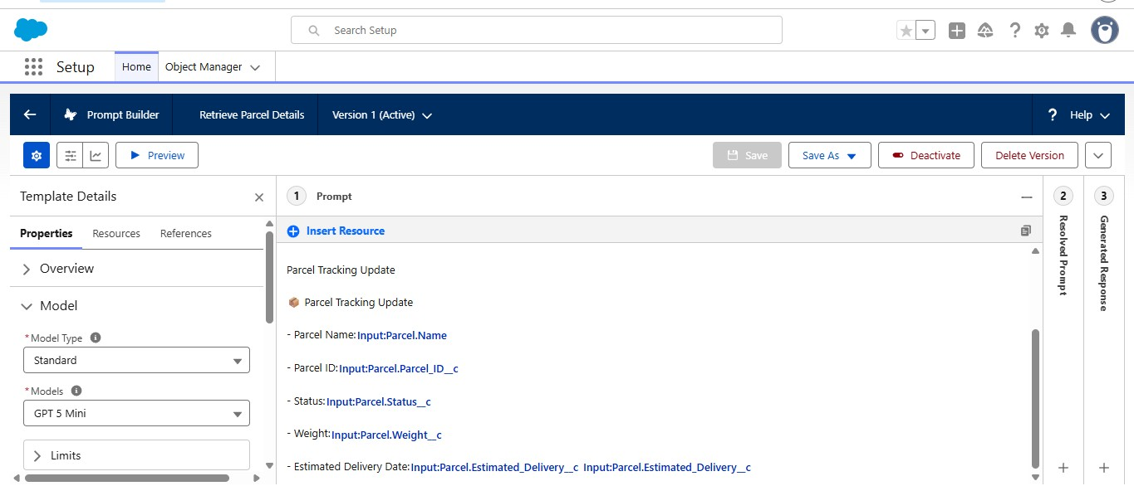
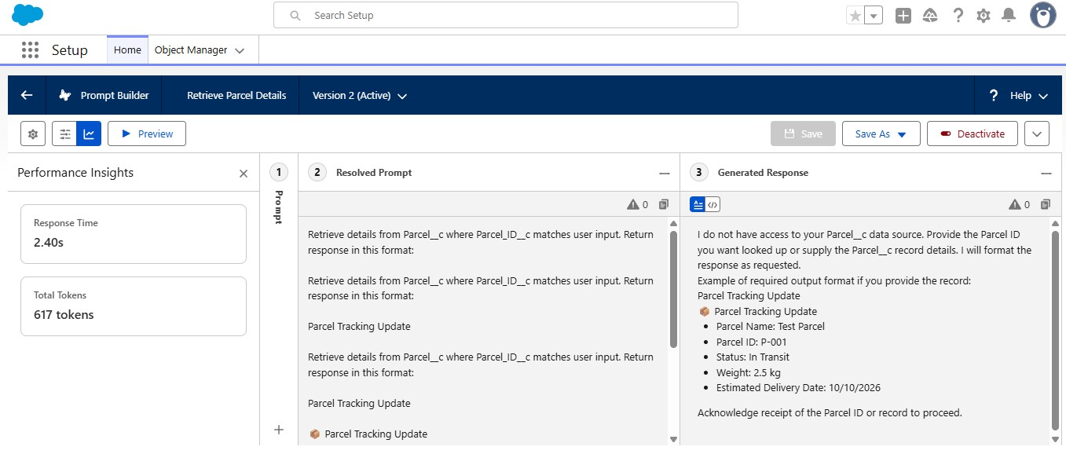
Flows:
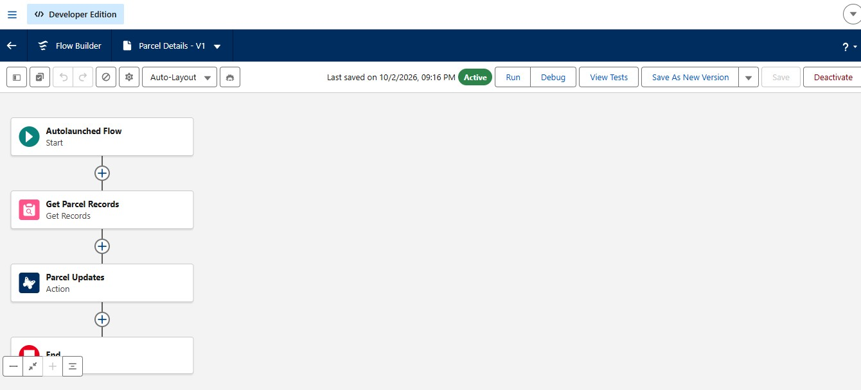
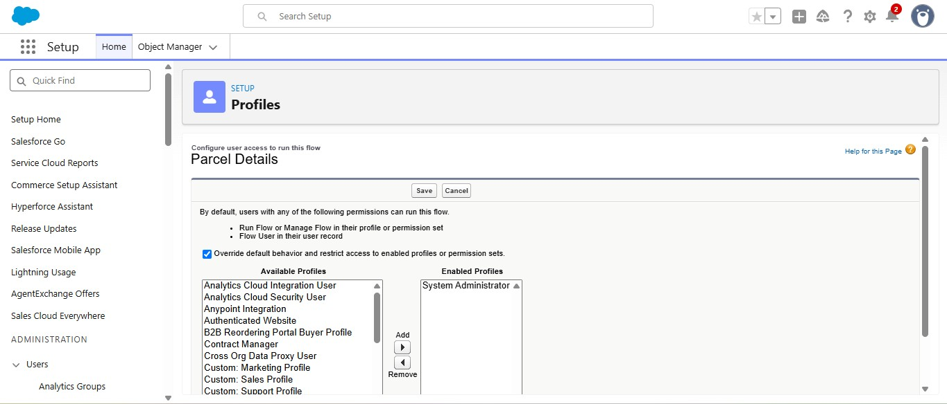

PHASE 3:UI&UX Development & Customization

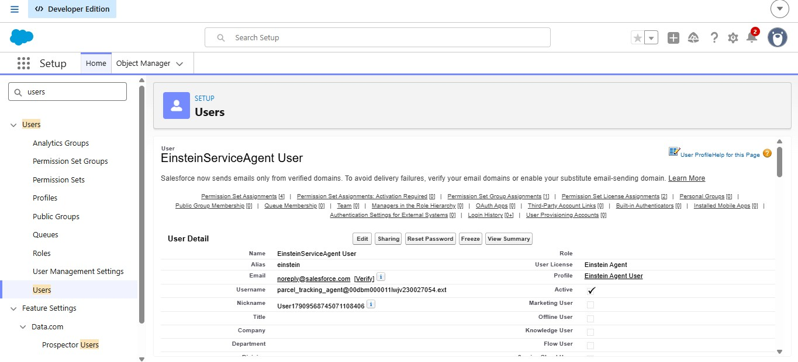

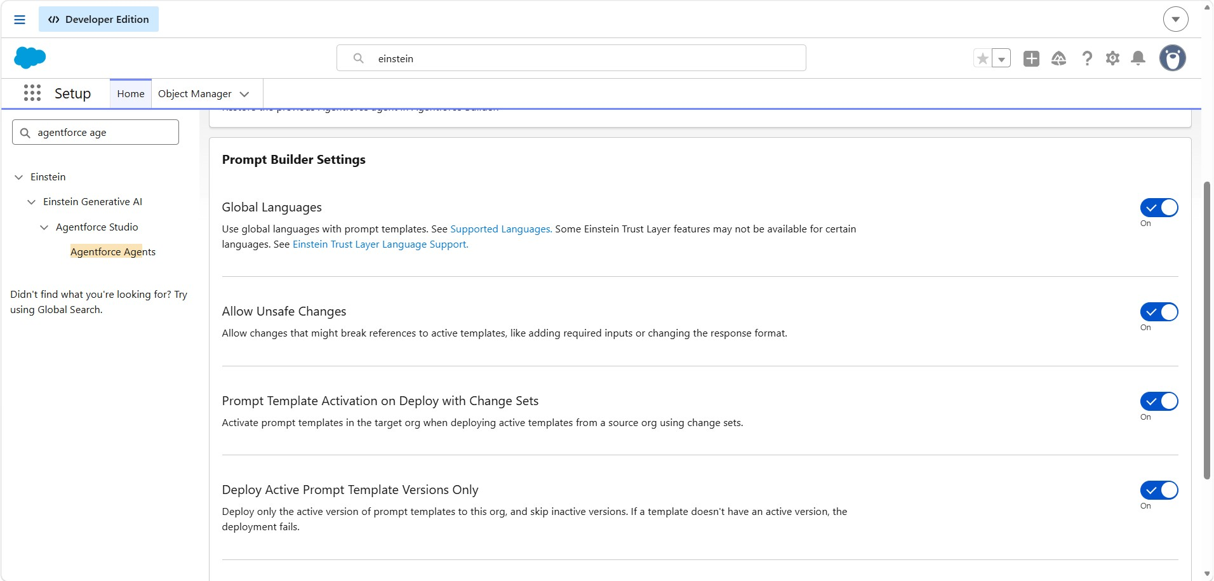

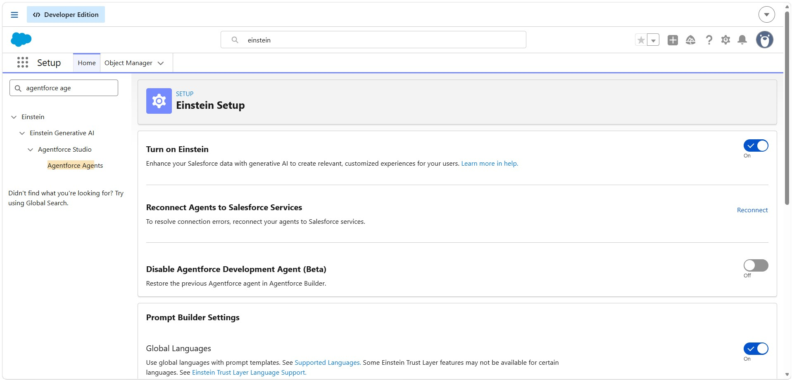

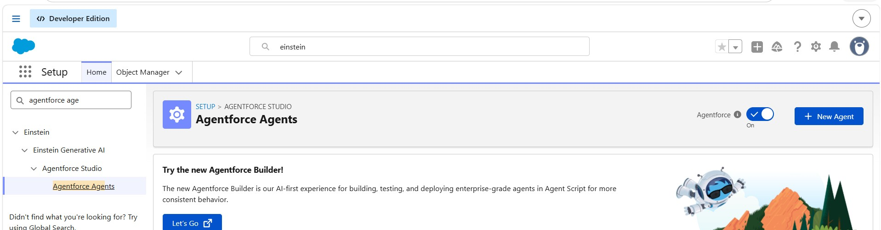

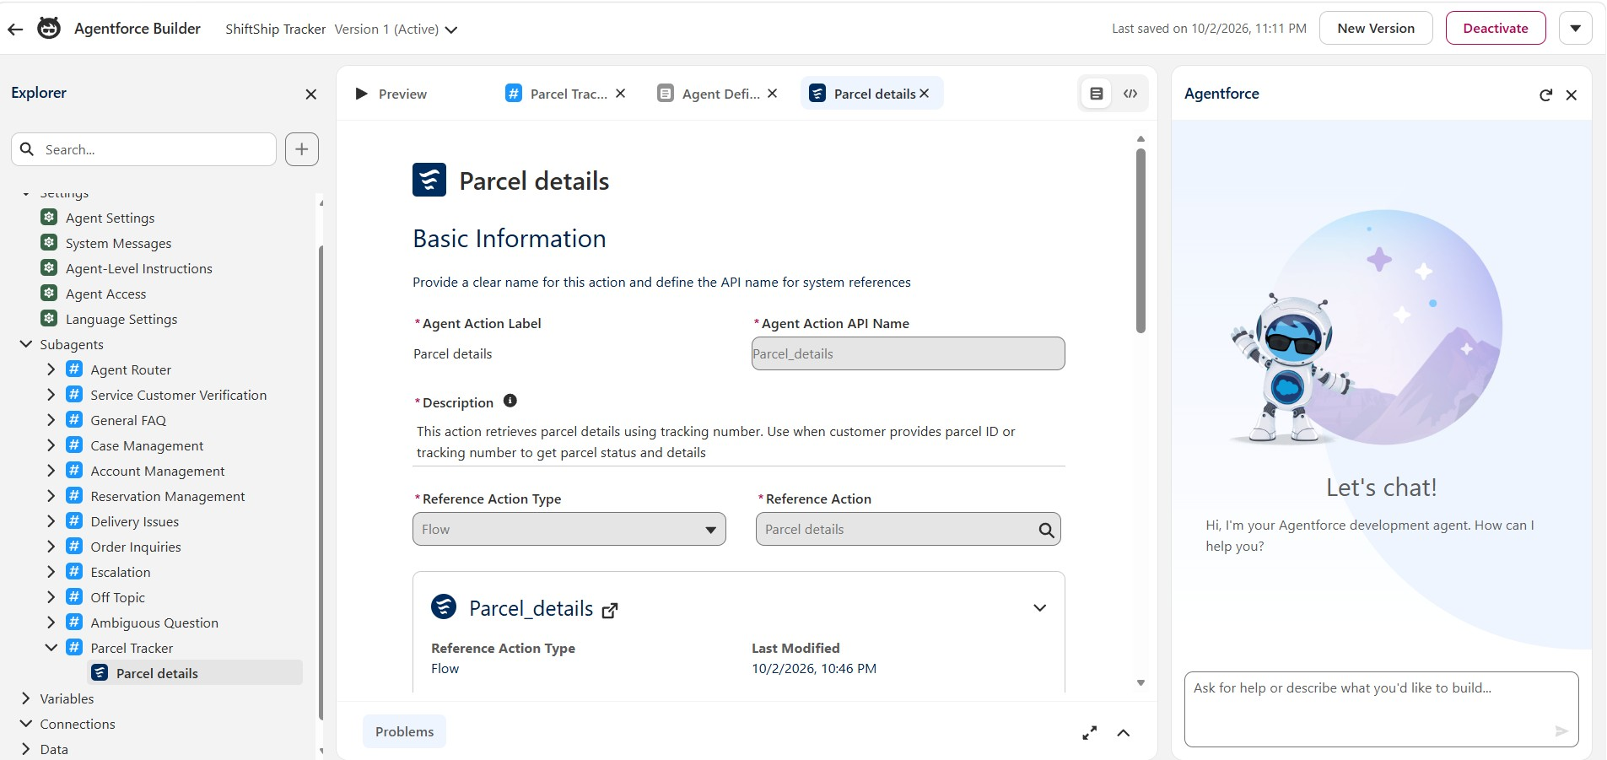
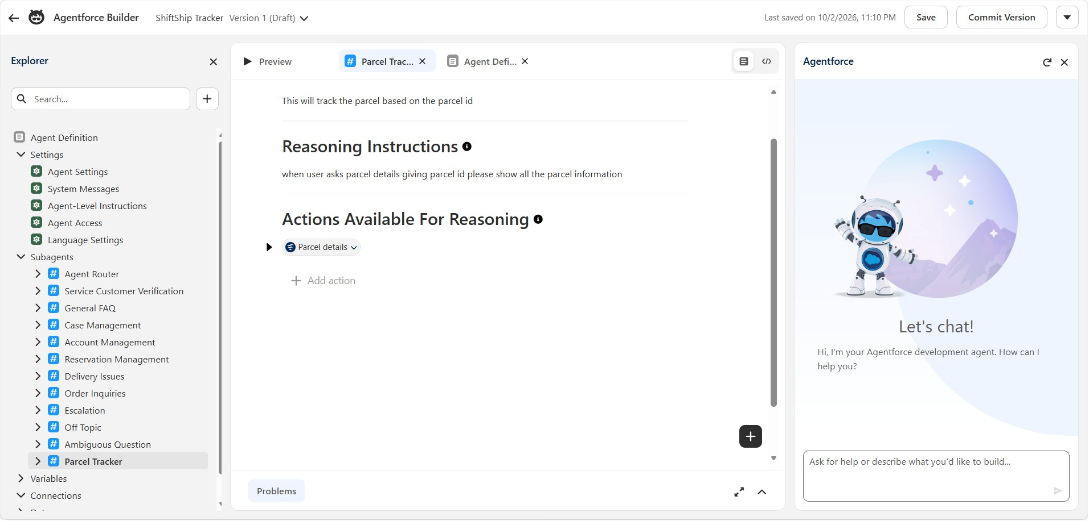
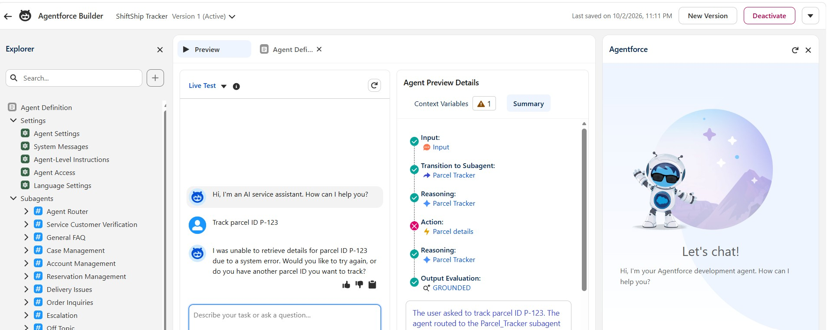
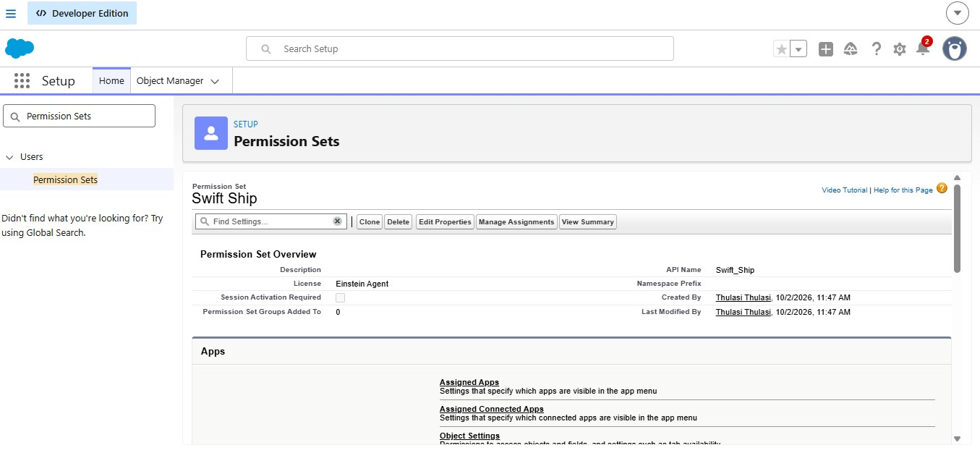

PHASE 4:Data migration,Testing& Security

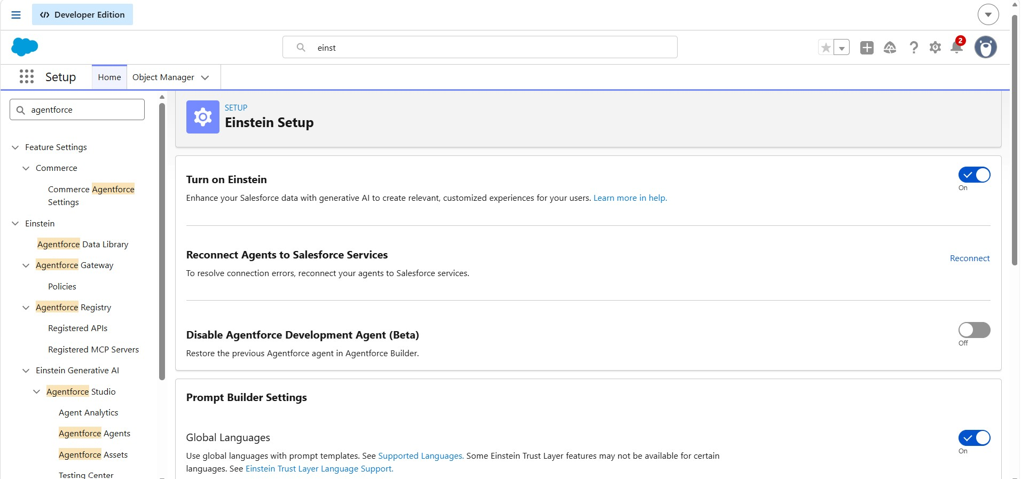

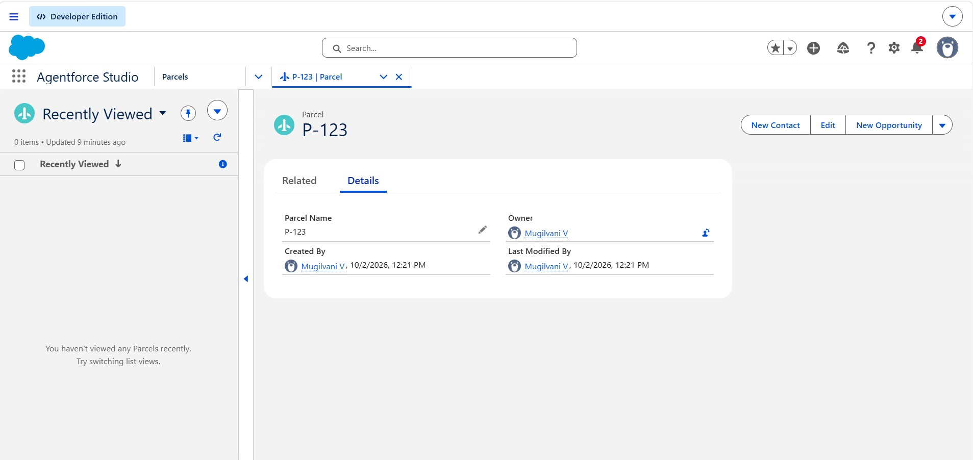

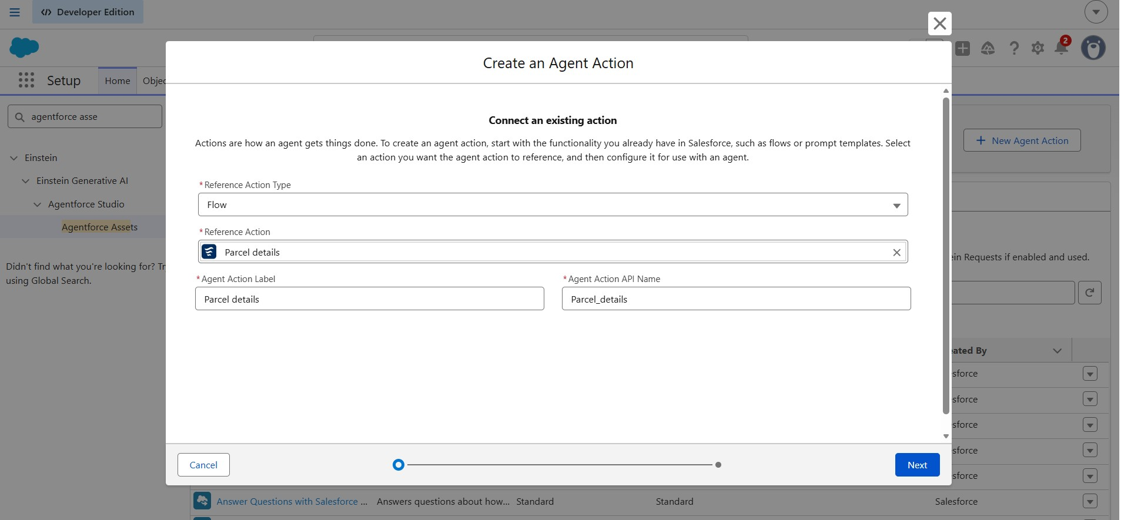

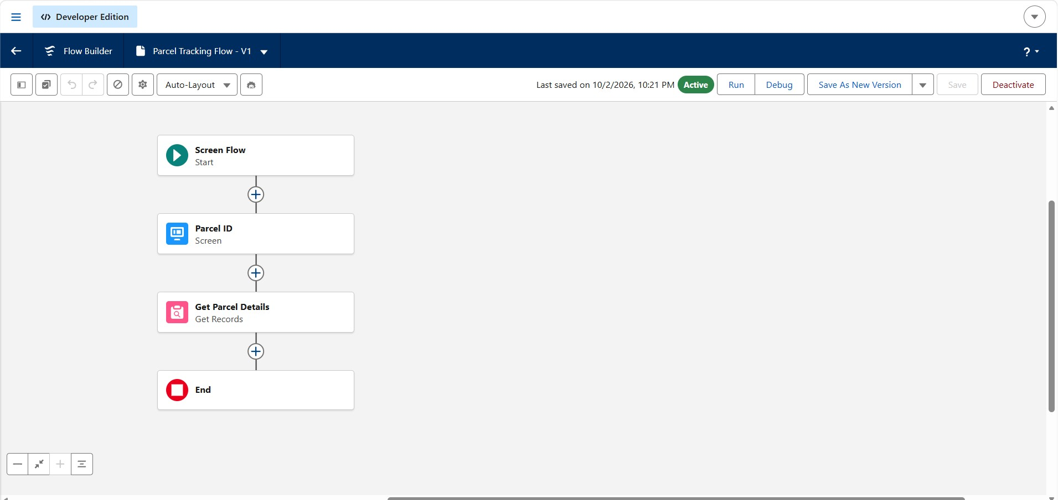

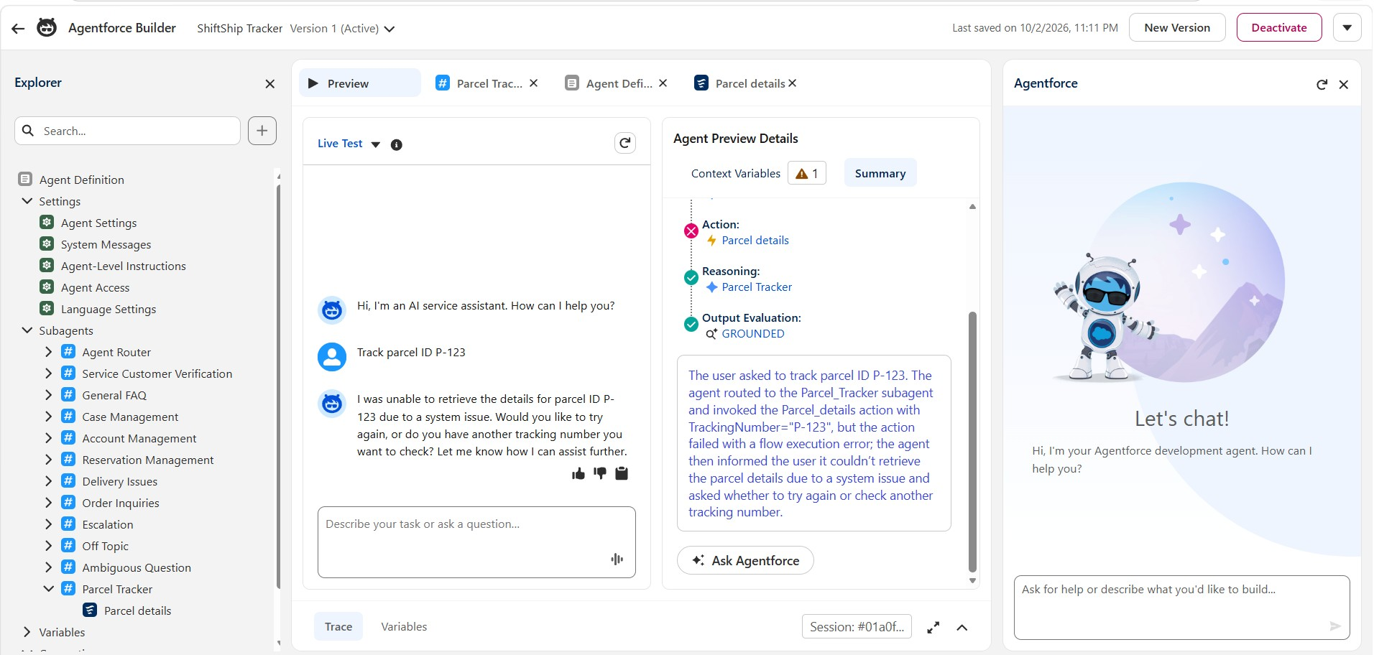

PHASE 5: MAINTENANCE, DOCUMENTATION &
PROJECT PRESENTATION
1. Maintenance, Monitoring & Troubleshooting
Maintenance and monitoring are important to ensure that the Swift Ship Tracker continues to function correctly after development.
The Salesforce configuration, Flows, AgentForce functionality and other project components should be monitored regularly to identify errors or unexpected behaviour.
The following activities are considered for maintenance and troubleshooting:
- Check the Salesforce Flows regularly to ensure that automation works correctly.
- Monitor parcel and delivery-related processes.
- Verify that the AgentForce functionality responds according to the configured requirements.
- Check user permissions and access when required.
- Test important functionalities after making configuration changes.
- Identify and troubleshoot errors occurring in Flows, objects, fields or AgentForce configurations.
- Keep the project documentation updated when major changes are made.
Regular monitoring helps maintain the reliability and usability of the Swift Ship Tracker system.

2. Project Documentation
The project documentation provides a complete record of the Swift Ship Tracker development process.
The documentation includes:
- Project overview
- Problem statement
- Project objectives
- Project scope
- User personas and requirements
- Salesforce features and tools
- Data model
- Security model
- Salesforce custom objects
- Custom tabs
- Fields and relationships
- Prompt Builder configuration
- Salesforce Flows
- AgentForce configuration
- Testing and verification
- Maintenance and troubleshooting
- Project conclusion
- Screenshots and other relevant evidence are included to demonstrate the completed project activities.
The documentation helps users, developers and evaluators understand the project structure, implementation and final outcome.

3. Project Demo Video Presentation
A project demo video is prepared to demonstrate the working of the Swift Ship Tracker project.
The demonstration presents the major features and functionalities implemented during the project.
The demo covers the relevant Salesforce configuration and project workflow, including:
- Custom objects
- Parcel-related information
- Sender and receiver information
- Delivery information
- Salesforce automation
- Prompt Builder functionality
- AgentForce functionality
- Flow execution
- Testing and verification
The demo video provides a practical overview of how the Swift Ship Tracker project works and demonstrates the completed implementation. Demo Video Link:
https://drive.google.com/file/d/1D52mQJw5nzAKn9GgSXkCbBfgMm gJi60u/view?usp=drivesdk

4. Conclusion
The Swift Ship Tracker project was developed as a Salesforce-based parcel delivery management solution.
The project covered requirement analysis, Salesforce backend configuration, custom objects, fields, relationships, automation using Salesforce Flows, Prompt Builder and AgentForce-related functionality.

